BRAC University
Department of Computer Science and Engineering

Spring – 2007
CSE110 (Programming Language-I)
Home Work
Due: At the beginning of next week’s lab class

Task 1:
Take a number form the user and find out if the number is prime or not?
Task 2:
What is the value of each of the following arithmetic expressions in Java? Explain your answer:
20/6
10/4.0
8/2-9+5
(8/2-9)+5
"a"+2+"b"
" "+"What"
Math.pow(36,0.5)
Math.pow(25,1/2)
Math.pow(1,7)-Math.pow(4,1/2.0)
"Math.pow(2,4)"+Math.pow(3,2)
"Math.pow(3,3"+"Math.pow(4,2)"
"A"+"B"+2+3+(3-2)
2*6+"A"+"B"+2+(3-2)
5+6-4*2/2+1
5+6-4*(2/2+1)
5 % 3
5.0 / 3
"23" + 3 + 4
4.0+2.0*(5.0+4.0/3.0)
4-(5+4/3)/3.0%2

Task 3:

Write the following expressions is Java.
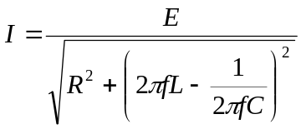
P = 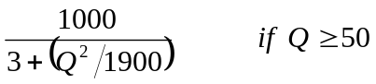
L = 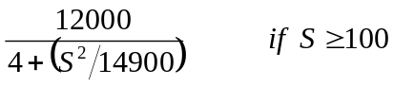

Task 4:
Change the following java code so that the “amount” of money is split into 100, 50, 20, 10, 5, 2 and 1 taka bills or coins. The output would be:
3 1 1
1 1 1 1

public class MoneySplit{
public static void main(String[] args){
int oneTaka = 0, twoTaka = 0, fiveTaka = 0, tenTaka = 0;
int twentyTaka = 0, fiftyTaka = 0, hundredTaka = 0;
int amount = 388;

System.out.println(hundredTaka + " " + fiftyTaka + " " + twentyTaka);
System.out.println(tenTaka + " " + fiveTaka + " " + twoTaka + " " + oneTaka);
}
}

Task 5:

public class Q4
{
public static void main(String args[])
{
boolean var1 = false, var2 = false, var3 = false, var4 = false,var5 = false;
boolean var6 = false, result1 = false, result2 = false, result3 = false, result4 = false;
boolean result5 = false, result6 = false, result7 = false, result8 = false;
boolean result9 = false, result10 = false;
var1 = 4 > 3 - 1;
var2 = var1 && false;
var3 = true;
var4 = false;
var5 = true;
var6 = var3 && false;
result1 = (var1 || var2) && (8 * 10 > 45);
result2 = (var1 || var2) && (result1 && false);
result3 = (var1 && result1) || result2;
result4 = (var1 || var2) || ((var3 && var1) && false);
result5 = (var1 && var2) && (result3 || var1);
result6 = ((var3 || var2) && !(result5)) || true;
result7 = (var4 && result1) && ((result1 && false) || true);
result8 = ((var1 && result3) && (var5 || var6)) && true;
result9 = ((result2 && var2) || (result7 && var1)) && false;
result10 = !(var1 && true);
}
}
Show the values of the result variables in the above program:

result1
result2
result3
result4
result5
result6
result7
result8
result9
result10

